Artboard Size
Aromixx White Coffee:
- W: 1200px ; H: 900px
- W: 1200px ; H: 900px
- W: 1200px ; H: 900px
- W: 1200px ; H: 900px
AROMIXX WHITE COFFEE
- First Page
Text: IPOH INSTANT [Font type: Helvetica Neue, Black]
Colour Code: #000000

White Coffee [Font type: Lobster 1.4, Regular]
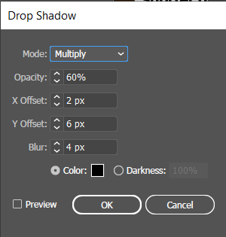
Colour Code: #FFFFFF

Your daily dose of [Font type: Helvetica Neue LT Pro, 77 Bold Condensed Oblique]
Clean Energy [Font type: Helvetica Neue LT Pro, 77 Bold Condensed Oblique]
Focus [Font type: Helvetica Neue LT Pro, 77 Bold Condensed Oblique]
Mental Clarity [Font type: Helvetica Neue LT Pro, 77 Bold Condensed Oblique]

- Second Page

Text:
-Smooth, rich, aromatic white coffee [Font type: Montserrat, ExtraBold]
(Your Effortless Solution For Delicious Drink At Home/Office) [Font type: Helvetica LT Std, Bold Condensed]
-Energy boost anywhere, anytime [Font type: Montserrat, ExtraBold]
(Take it to trip, work, school, party, gathering on-the-go) [Font type: Helvetica LT Std, Bold Condensed]
-Lighter brew, higher caffeine [Font type: Montserrat, ExtraBold]
(Ideal option for morning drink help you to wake up [Font type: Helvetica LT Std, Bold Condensed]
-Shorter roasting time white coffee [Font type: Montserrat, ExtraBold]
(Reduce blood pressure) [Font type: Helvetica LT Std, Bold Condensed]
(Less acidic, more powerful antioxidant, comfort drink for anyone) [Font type: Helvetica LT Std, Bold Condensed]
-Nutty flavour or bitter taste? [Font type: Montserrat, ExtraBold]
(White coffee has nutty flavour with low bitterness, suitable for non-coffee lover) [Font type: Helvetica LT Std, Bold Condensed]
-Versatile Beverage all day long [Font type: Montserrat, ExtraBold]
(Enjoy hot or cold, just add water) [Font type: Helvetica LT Std, Bold Condensed]

Colour Code: #000000

Colour Code: #FFFFFF

